Maharshi Dayanand University, Rohtak

**Report**

**Of**

**Minor Project**

**STUDENT RESULT**

**CALCULATOR**

**&**

**WEIGHT CONVERTOR**



**MASTER OF COMPUTER SCIENCE AND APPLICATION**

**DEPARTMENT OF COMPUTER SCIENCE AND APPLICATION**

**Submitted To:- Submitted By:-**

DR. NASIB SINGH GILL ANKIT

( Professor In DCSA) ROLL NO:- 17321

MDU MCA 3rd yr.(5th sem)

***INDEX***

|  |  |  |
| --- | --- | --- |
| ***S. No*** | ***Title*** | ***Page No.*** |
| 1. | CERTIFICATE | 3 |
| 2. | ACKNOWLEDGEMENT | 4 |
| 3. | About theProject | 5-7 |
| 4. | System Requirements Analysis | 8 |
| 5. | Coding | 9-40 |
| 6. | Output Screens | 41-46 |

***CERTIFICATE***

This is to certify that project that dissertation/project report entitled “STUDENT RESULT CALCULATOR & WEIGHT CONVERTOR” done by “ANKIT” is an authentic work carried out by him at Limited under my guidance. The matter inputted in this project work has not been submitted earlier for the award of any degree or diploma to best of my knowledge and belief.

**Signature………………………**

***ACKNOWLEDGEMENT***

We gratefully acknowledge for the assistance, cooperation, guidance and clarifications provided by **MDU** during the development of the

“**STUDENT RESULT CALCULATOR**

**&**

**WEIGHT CONVERTOR**”

Our extreme gratitude to **Dr. NASIB SINGH GILL.**who guided us throughout the project. Without his willing disposition, spirit of accommodation, frankness, timely clarification and above all faith in us, this project could not have been completed in due time.

His readiness to discuss all important matters at work deserves special attention. We would also like to thank whole of the faculty of the department for their cooperation and important support.

**ANKIT**

**INTRODUCTION**

**1.1 ABSTRACT**

STUDENT GRADE CALCULATOR & WEIGHT CONVERTOR is a software in which we have specified some operations, firstly user enter user name and password to enter in the STUDENT GRADE CALCULATOR & WEIGHT CONVERTOR. In this , user can calculate grades by entering marks

And can easily find percentage and grade of a student . and can also covert the weight from pounds to kilogram or grams etc.

The environment used for this project is HTML, CSS, JAVA SCRIPT, BOOTSTRAP.

1.2 **OBJECTIVES**

This concept of Student grade calculator & weight convertor fulfils the following requirements:

* It provides a less expensive as well as an effective method of finding percentage and grades of a student.
* We can convert the weight from one measurement to anoter very easily.
* It saves time as well as money.
* It is easy to use.
  1. AREAS OF APPLICATION
* **Across the globe**: This project finds it application in keeping records over the globe.
* **Customer’s needs**: It saves time as well as money. It lessens customer’s frustration.

**SYSTEM ANALYSIS**

**2.1 FEASIBILITY STUDY**

Feasibility study defines all the requirements to performance characteristics of system.

For system to be feasible, the design needs to undertake various factors or performance requirements by which the system will be operated.

A feasibility study is short, focused study which aims at selecting the best system that meets performance requirements. Information is gathered regarding the general requirements of the proposed system.

If feasibility study is to serve as the decision document, it answers a number of questions.

Like

* Is it beneficial?
* Does it save time and money?
* Can it be integrated with other systems already in place?

Planning resources is a very vast concept and we are beginners, thus including each and every aspects of web, Integrate and automate them in every respect was not feasible for us. Hence we perform feasibility study to make our project compatible for present environment. The concept of student grade calculator & weight convertor newer. The project is built with the help of **HTML,CSS,JAVA SCRIPT,BOOTSTRAP** technology which is reliable and efficient platform to work upon. This concept saves time and lessens the customer frustration.

**2 .1.1 Technical feasibility**

Technical feasibility takes of the all the issues concerned with the design and the development part of the project. It concerns itself with the software, hardware and the platform related issues. The following are the technical specifications for our project.

The project would require a lot of space for storage of static as well as dynamic content.

As the number of project available increases the space required for storing them increases.

2.2 **HARDWARE AND SOFTWARE REQUIREMENT**

**Software Requirements**

Operating System : Window 2007, 2010

Front End : HTML, CSS, JAVA SCRIPT, BOOT STRAP

**Hardware Requirements**

Machine : Pentium 4

Speed : 233 MHz and above

Hard Disk : 512GB

RAM : 4GB

**CODING:**

**LOG IN :**

<!DOCTYPE html>

<html lang="en">

<head>

<meta charset="UTF-8">

<meta name="viewport" content="width=device-width, initial-scale=1.0">

<meta http-equiv="X-UA-Compatible" content="ie=edge">

<title>Login Page</title>

<link rel="stylesheet" href="https://stackpath.bootstrapcdn.com/bootstrap/4.1.3/css/bootstrap.min.css"> <linkhref="https://fonts.googleapis.com/css?family=Righteous&display=swap" rel="stylesheet"> <link rel="stylesheet" href="https://cdnjs.cloudflare.com/ajax/libs/animate.css/3.7.2/animate.min.css">

<link rel="stylesheet" href="https://cdnjs.cloudflare.com/ajax/libs/font-awesome/4.7.0/css/font-awesome.min.css">

<style>

html,body

{

background-image: url('544750.jpg');

background-size: cover;

background-repeat: no-repeat;

height: 100%;

font-family: 'Righteous', cursive;

}

.container{

height: 100%;

align-content: center;

}

.card{

height: 370px;

margin-top: auto;

margin-bottom: auto;

width: 400px;

background-color: rgba(0,0,0,0.5) !important;

}

.social_icon span{

font-size: 60px;

margin-left: 10px;

color: #FFC312;

}

.social_icon span:hover{

color: white;

cursor: pointer;

}

.card-header h3

{

color: white;

}

.social_icon{

position: absolute;

right: 20px;

top: -45px;

}

.input-group-prepend span{

width: 50px;

background-color: #FFC312;

color: black;

border:0 !important;

}

input:focus{

outline: 0 0 0 0 !important;

box-shadow: 0 0 0 0 !important;

}

.remember{

color: white;

}

.remember input

{

width: 20px;

height: 20px;

margin-left: 15px;

margin-right: 5px;

}

.login_btn{

color: black;

background-color: #FFC312;

width: 100px;

}

.login_btn:hover{

color: black;

background-color: white;

}

.links{

color: white;

}

.links a{

margin-left: 4px;

}

</style>

</head>

<body>

<div class ="container" >

<div class="d-flex justify-content-center h-100">

<div class="card">

<div class="card-header">

<h3>Sign In</h3>

<div class="d-flex justify-content-end social_icon"> <ahref="https://www.facebook.com/?stype=lo&jlou=AfdweqzpXXgE_qZNjO8ygNyrOGLq25f_bE0Z9C5Mgpyrf5DbCoOIdI2Q7mqea9n4Y10NyOIsVhXn9siO1_P2_otnLi1La_iNy3JkeqdJIsIQFQ&smuh=18707&lh=Ac9LkeDdDiM8yTVj"><span><i class="fa fa-facebook-square"></i></span></a>

<a href="https://accounts.google.com/ServiceLogin?service=CPanel" >

<span><i class="fa fa-google-plus-square"></i></span></a>

<a href="https://twitter.com/login"><span>

<i class="fa fa-twitter-square"></i></span></a>

</div>

</div>

<div class="card-body">

<form>

<div class="input-group form-group">

<div class="input-group-prepend">

<span class="input-group-text"><i class="fa fa-user"></i></span>

</div>

<input type="text" class="form-control" placeholder="Username">

</div>

<div class="input-group form-group">

<div class="input-group-prepend">

<span class="input-group-text"><i class="fa fa-key"></i></span>

</div>

<input type="password" class="form-control" placeholder="Password">

</div>

<div class="row align-items-center remember">

<input type="checkbox">Remind Me

</div>

</form>

<div class="form-group">

<a href="file.html" > <button class="btn float-right login_btn">Log in</button></a>

</div>

</div>

<div class="card-footer">

<div class="d-flex justify-content-center links">

Don't have an account?<a href="signup.html">Sign Up</a>

</div>

<div class="d-flex justify-content-center">

<a href="#">Forgot your password?</a>

</div>

</div>

</div>

</div>

</body>

</html>

**SIGN UP:**

<!DOCTYPE html>

<html lang="en">

<head>

<meta charset="UTF-8">

<meta name="viewport" content="width=device-width, initial-scale=1.0">

<meta http-equiv="X-UA-Compatible" content="ie=edge">

<title>Sign up</title>

<link rel="stylesheet" href="https://stackpath.bootstrapcdn.com/bootstrap/4.1.3/css/bootstrap.min.css">

<linkhref="https://fonts.googleapis.com/css?family=Righteous&display=swap" rel="stylesheet">

<link rel="stylesheet" href="https://cdnjs.cloudflare.com/ajax/libs/animate.css/3.7.2/animate.min.css">

<link rel="stylesheet" href="https://cdnjs.cloudflare.com/ajax/libs/font-awesome/4.7.0/css/font-awesome.min.css">

<style>

html,body

{

background-image: url("signupbackground.jpg");

background-size: cover;

background-repeat: no-repeat;

height: 100%;

font-family: 'Righteous', cursive;

}

.container

{

height:100%;

align-content: center;

}

.card

{

height: 400px;

margin-top: 110px;

margin-bottom: auto;

width: 420px;

background-color: rgba(0,0,0,0.5) ;

}

.card-header h3

{

color:white;

}

.card-header h5

{

color:white;

}

.input-group-prepend span

{

width: 50px;

background-color:greenyellow;

color: black;

border:0 !important;

}

.social_icon span

{

font-size: 60px;

margin-left: 10px;

color:greenyellow;

}

.social_icon

{

position: absolute;

right: 20px;

top: -50px;

}

.social_icon span:hover

{

color: white;

cursor: pointer;

}

.signup_btn

{

color: black;

background-color:greenyellow;

width: 100px;

}

.signup_btn:hover

{

color: black;

background-color: white;

}

</style>

</head>

<body>

<div class="container" >

<div class="d-flex justify-content-center h-150">

<div class="card">

<div class="card-header">

<h3> Sign up </h3>

<h5>Create account it's quick & easy!</h5>

<div class="d-flex justify-content-end social_icon">

<ahref="https://www.facebook.com/?stype=lo&jlou=AfdweqzpXXgE_qZNjO8ygNyrOGLq25f_bE0Z9C5Mgpyrf5DbCoOIdI2Q7mqea9n4Y10NyOIsVhXn9siO1_P2_otnLi1La_iNy3JkeqdJIsIQFQ&smuh=18707&lh=Ac9LkeDdDiM8yTVj"><span><i class="fa fa-facebook-square"></i></span></a>

<a href="https://accounts.google.com/ServiceLogin?service=CPanel" ><span><i class="fa fa-google-plus-square"></i></span></a>

<a href="https://twitter.com/login"><span><i class="fa fa-twitter-square"></i></span></a>

</div>

</div>

<div class="card-body">

<form>

<div class="input-group form-group">

<div class="input-group-prepend">

<span class="input-group-text"><i class="fa fa-user"></i></span>

</div>

<input type="text" class="form-control" placeholder="First name">

</div>

<div class="input-group form-group">

<div class="input-group-prepend">

<span class="input-group-text"><i class="fa fa-user"></i></span>

</div>

<input type="text" class="form-control" placeholder="Surname">

</div>

<div class="input-group form-group">

<div class="input-group-prepend">

<span class="input-group-text"><i class="fa fa-user"></i></span>

</div>

<input type="text" class="form-control" placeholder="E-mail Address or Mobile number">

</div>

<div class="input-group form-group">

<div class="input-group-prepend">

<span class="input-group-text"><i class="fa fa-key"></i></span>

</div>

<input type="password" class="form-control" placeholder="New Password">

</div>

</form>

<div class="form-group">

<a href="file.html" > <button class="btn float-right signup_btn">Sign up</button></a>

</div>

</div>

</div>

</div>

</div>

</body>

</html>

**HOME:**

<!DOCTYPE html>

<html lang="en">

<head>

<meta charset="UTF-8">

<meta name="viewport" content="width=device-width, initial-scale=1.0">

<meta http-equiv="X-UA-Compatible" content="ie=edge">

<title>Dropdown</title> <linkrel="stylesheet"href="https://maxcdn.bootstrapcdn.com/bootstrap/4.3.1/css/bootstrap.min.css"> <linkhref="https://fonts.googleapis.com/css?family=Righteous&display=swap" rel="stylesheet"> <linkel="stylesheet"href="https://cdnjs.cloudflare.com/ajax/libs/animate.css/3.7.2/animate.min.css">

<link rel="stylesheet" href="https://cdnjs.cloudflare.com/ajax/libs/font-awesome/4.7.0/css/font-awesome.min.css">

<style>

body

{

background-image: url('abandoned-forest-hd-wallpaper-34950.jpg');

background-size: cover;

background-repeat: no-repeat;

font-family: 'Righteous', cursive;

}

.card

{

height: 260px;

margin-top: 30%;

background-color: rgba(0,0,0,0.5) !important;

margin-left: 30%;

width: 350px;

}

.card h4

{

color: white;

}

.create1_btn

{

color: black;

background-color:lightgreen;

width: 100px;

}

.card-body h5

{

color:white;

}

</style>

</head>

<body>

<nav class="navbar navbar-expand-lg navbar-light bg-light" >

<div class="collapse navbar-collapse" id="navbarSupportedContent">

<ul class="navbar-nav mr-auto">

<li class="nav-item active">

<a class="nav-link" href="file.html">Home</a>

</li>

<li class="nav-item">

<a class="nav-link active" href="aboutus.html">About us</a>

</li>

<li class="nav-item">

<a class="nav-link active" href="calculator.html">Student Grade Calculator</a>

</li>

<li class="nav-item">

<a class="nav-link active" href="convertor.html">Weight Convertor</a>

</li>

</ul>

<div class="form-inline my-2 my-lg-0">

<a href="login.html" > <button class="btn btn-outline-success my-2 my-sm-0" href="login.html">Sign in</button></a>

</div>

</div>

</nav>

<div class="row">

<div class="col-md-5">

<div class="card">

<div class="card-header">

<h4>Student Grade Calculator</h4>

</div>

<div class="card-body">

<form>

<h5>Here you can calculate your grades in few seconds by filling some details try this click on calculate button </h5>

<a href="calculator.html" class="btn btn-info" role="button">Calculate</a>

</form>

</div>

</div>

</div>

<div class="col-md-5">

<div class="card" >

<div class="card-header">

<h4>Weight Convertor</h4>

</div>

<div class="card-body">

<form>

<h5>Here you can convert the weight in any form in few seconds by filling some details click on convert button </h5>

<a href="convertor.html" class="btn btn-info" role="button">Convert</a>

</form>

</div>

</div>

</div>

</div>

</body>

</html>

**STUDENT GRADE CALCULATOR:**

<!DOCTYPE html>

<html>

<head>

<title></title>

<link ref="https://fonts.googleapis.com/css?family=Righteous&display=swap" rel="stylesheet"> <linkrel="stylesheet"ef="https://cdnjs.cloudflare.com/ajax/libs/animate.css/3.7.2/animate.min.css">

<link rel="stylesheet" href="https://cdnjs.cloudflare.com/ajax/libs/font-awesome/4.7.0/css/font-awesome.min.css"> <linkrel="stylesheet"href="https://stackpath.bootstrapcdn.com/bootstrap/4.1.3/css/bootstrap.min.css">

<style>

body {

background:#33d9b2;

font-size: 16px;

}

body, button, input {

font-family: 'Righteous', cursive;

font-weight: 700;

letter-spacing: 1.4px;

}

.background {

display: flex;

min-height: 100vh;

}

.container {

flex: 0 1 700px;

margin: auto;

padding: 10px;

}

.screen {

position: relative;

background: #3e3e3e;

border-radius: 15px;

}

.screen:after {

content: '';

display: block;

position: absolute;

top: 0;

left: 20px;

right: 20px;

bottom: 0;

border-radius: 15px;

box-shadow: 0 20px 40px rgba(0, 0, 0, .4);

z-index: -1;

}

.screen-body {

display: flex;

}

.screen-body-item {

flex: 1;

padding: 50px;

}

.screen-body-item.left {

display: flex;

flex-direction: column;

justify-content: center;

align-items: center;

}

.app-title {

display: flex;

justify-content: center;

align-items: center;

color: #33d9b2;

font-size: 26px;

text-transform: uppercase;

border-left: 4px solid #218c74;

padding: 10px;

}

.app-form-group {

margin-bottom: 15px;

}

.app-form-group.buttons {

margin-bottom: 0;

text-align: right;

}

.app-form-control {

width: 100%;

padding: 10px 0;

background: none;

border: none;

border-bottom: 1px solid #666;

color: #ddd;

font-size: 14px;

text-transform: uppercase;

outline: none;

transition: border-color .2s;

}

.app-form-control::placeholder {

color: #FFF;

}

.app-form-control:focus {

border-bottom-color: #ddd;

}

.app-form-button {

background: none;

border: none;

color: #33d9b2;

font-size: 14px;

cursor: pointer;

outline: none;

text-transform: uppercase;

}

.app-form-button:hover {

color: #218c74;

}

.showdata{

text-align: center;

color: white;

font-size: 1.2rem;

padding-top: -10px;

padding-bottom: 10px;

}

</style>

</head>

<body>

<nav class="navbar navbar-expand-lg navbar-light bg-light fixed-top" >

<div class="collapse navbar-collapse" id="navbarSupportedContent">

<ul class="navbar-nav mr-auto">

<li class="nav-item active">

<a class="nav-link" href="file.html">Home</a>

</li>

<li class="nav-item">

<a class="nav-link active" href="aboutus.html">About us</a>

</li>

<li class="nav-item">

<a class="nav-link active" href="calculator.html">Student Grade Calculator</a>

</li>

<li class="nav-item">

<a class="nav-link active" href="convertor.html">Weight Convertor</a>

</li>

</ul>

<div class="form-inline my-2 my-lg-0">

<a href="login.html"> <button class="btn btn-outline-success my-2 my-sm-0" type="submit">Sign in</button></a>

</div>

</div>

</nav>

<div class="background">

<div class="container">

<div class="screen">

<div class="screen-body">

<div class="screen-body-item left">

<div class="app-title">

<div class="animated infinite pulse">

Student <br> Grade <br> Calulator

</div>

</div>

</div>

<div class="screen-body-item">

<div class="app-form">

<div class="app-form-group">

<input type="text" class="app-form-control" placeholder="DATA MINING" id="dt">

</div>

<div class="app-form-group">

<input type="text" class="app-form-control" placeholder="SOFT COMPUTING" id="sc">

</div>

<div class="app-form-group">

<input type="text" class="app-form-control" placeholder="INTERNET OF THINGS" id="iot">

</div>

<div class="app-form-group">

<input type="text" class="app-form-control" placeholder="SOFTWARE TESTING" id="st" >

</div>

<div >

<input type="button" name="" value="showPercentage" class="app-form-button" onclick="calcy()">

</div>

</div>

</div>

</div>

<div class="app-form-group showdata">

<p id="showData" > </p>

</div>

</div>

</div>

<script>

const calcy = () =>{

let dt = document.getElementById('dt').value;

let sc = document.getElementById('sc').value;

let iot = document.getElementById('iot').value;

let st = document.getElementById('st').value;

let grades = "";

let totalGrades = parseFloat(dt) + parseFloat(sc) + parseFloat(iot) + parseFloat(st);

alert(totalGrades);

let perc = (totalGrades/400) * 100;

alert(perc);

if(perc <= 100 && perc >= 90){

grades = 'A+';

}else if(perc <= 89.5 && perc >= 80){

grades = 'A';

}else if(perc <= 79.5 && perc >= 70){

grades = 'B+';

}else if(perc <= 69.5 && perc >= 60){

grades = 'B';

}else if(perc <= 59.5 && perc >= 50){

grades = 'C+';

}else if(perc <= 49.5 && perc >= 40){

grades = 'C';

}

else{

grades = 'D';

}

if(perc >= 39.5)

{

document.getElementById('showData').innerHTML = ` Out of 400 your total is ${totalGrades} and percentage is ${perc}%. <br> Your grade is ${grades}. You are Pass. `

}

Else

{

document.getElementById('showData').innerHTML = ` Out of 400 your total is ${totalGrades} and percentage is ${perc}%. <br> Your grade is ${grades}. You are Fail. `

}

}

</script>

</body>

</html>

**WEIGHT CONVERTOR:**

<!DOCTYPE html>

<html lang="en">

<head>

<meta charset="UTF-8">

<meta name="viewport" content="width=device-width, initial-scale=1.0">

<meta http-equiv="X-UA-Compatible" content="ie=edge">

<title>Weight Convertor</title>

<linkrel="stylesheet"href="https://stackpath.bootstrapcdn.com/bootstrap/4.1.3/css/bootstrap.min.css">

<link rel="stylesheet" href="https://cdnjs.cloudflare.com/ajax/libs/font-awesome/4.7.0/css/font-awesome.min.css">

<linkhref="https://fonts.googleapis.com/css?family=Righteous&display=swap" rel="stylesheet">

<style>

body{

margin-top:70px;

background:#33d9b2;

color:black;

font-family: 'Righteous', cursive;

}

</style>

</head>

<body>

<nav class="navbar navbar-expand-lg navbar-light bg-light fixed-top" >

<div class="collapse navbar-collapse" id="navbarSupportedContent">

<ul class="navbar-nav mr-auto">

<li class="nav-item active">

<a class="nav-link" href="file.html">Home</a>

</li>

<li class="nav-item">

<a class="nav-link active" href="aboutus.html">About us</a>

</li>

<li class="nav-item">

<a class="nav-link active" href="calculator.html">Student Grade Calculator</a>

</li>

<li class="nav-item">

<a class="nav-link active" href="convertor.html">Weight Convertor</a>

</li>

</ul>

<div class="form-inline my-2 my-lg-0">

<a href="login.html"> <button class="btn btn-outline-success my-2 my-sm-0" type="submit">Sign in</button></a>

</div>

</div>

</nav>

<div class="container">

<div class="row">

<div class="col-md-6 offset-md-3">

<h1 class="display-4 text-center mb-3">Weight Converter</h1>

<form>

<div class="form-group">

<input id="lbsInput" type="number" class="form-control form-control-lg" placeholder="Enter Pounds">

</div>

</form>

<div id="output">

<div class="card mb-3">

<div class="card-block">

<h4>Grams:</h4>

<div id="gramsOutput"></div>

</div>

</div>

<div class="card mb-3">

<div class="card-block">

<h4>Kilograms:</h4>

<div id="kgOutput"></div>

</div>

</div>

<div class="card mb-3 ">

<div class="card-block">

<h4>Ounces:</h4>

<div id="ozOutput"></div>

</div>

</div>

</div>

</div>

</div>

</div>

<script>

document.getElementById("output").style.visibility = "hidden";

document.getElementById("lbsInput").addEventListener("input", function(e) { document.getElementById("output").style.visibility = "visible";

let lbs = e.target.value;

document.getElementById("gramsOutput").innerHTML = lbs / 0.0022046;

document.getElementById("kgOutput").innerHTML = lbs / 2.2046;

document.getElementById("ozOutput").innerHTML = lbs * 16;

});

</script>

</body>

</html>

**ABOUT US:**

<!DOCTYPE html>

<html lang="en">

<head>

<meta charset="UTF-8">

<meta name="viewport" content="width=device-width, initial-scale=1.0">

<meta http-equiv="X-UA-Compatible" content="ie=edge">

<title>About Us</title>

<link rel="stylesheet" href="https://stackpath.bootstrapcdn.com/bootstrap/4.1.3/css/bootstrap.min.css">

<link rel="stylesheet" href="https://cdnjs.cloudflare.com/ajax/libs/font-awesome/4.7.0/css/font-awesome.min.css">

<linkhref="https://fonts.googleapis.com/css?family=Righteous&display=swap" rel="stylesheet"> <linkrel="stylesheet"href="https://cdnjs.cloudflare.com/ajax/libs/animate.css/3.7.2/animate.min.css">

<style>

html,body

{

background-image:url("aboutus.jpg");

background-size: cover;

background-repeat: no-repeat;

font-family: 'Righteous', cursive;

}

.card

{

height:420px;

width:400px;

margin-top: 8%;

background-color: rgba(0,0,0,0.5) !important;

}

.card-header h3

{

color:white;

}

.card-body h4

{

color:white;

}

</style>

</head>

<body>

<nav class="navbar navbar-expand-lg navbar-light bg-light fixed-top" >

<div class="collapse navbar-collapse" id="navbarSupportedContent">

<ul class="navbar-nav mr-auto">

<li class="nav-item active">

<a class="nav-link" href="file.html">Home</a>

</li>

<li class="nav-item">

<a class="nav-link active" href="aboutus.html">About us</a>

</li>

<li class="nav-item">

<a class="nav-link active" href="calculator.html">Student Grade Calculator</a>

</li>

<li class="nav-item">

<a class="nav-link active" href="convertor.html">Weight Convertor</a>

</li>

</ul>

<div class="form-inline my-2 my-lg-0">

<a href="login.html"> <button class="btn btn-outline-success my-2 my-sm-0" type="submit">Sign in</button></a>

</div>

</div>

</nav>

<div class="container ">

<div class="d-flex justify-content-center ">

<div class="card">

<div class="card-header">

<h3>About Us</h3>

</div>

<div class="card-body">

<h4> We are a grade calculator and weight convetor company with the help of us you can easily calculate your marks with in few seconds by just entring the require details which were asked

while calculating ! Here you can calcultae grades or convert weight in any format you want ! :)

</h4>

</div>

</div>

</div>

</div>

</body>

</html>

**OUTPUT:**

1. **Login page :**

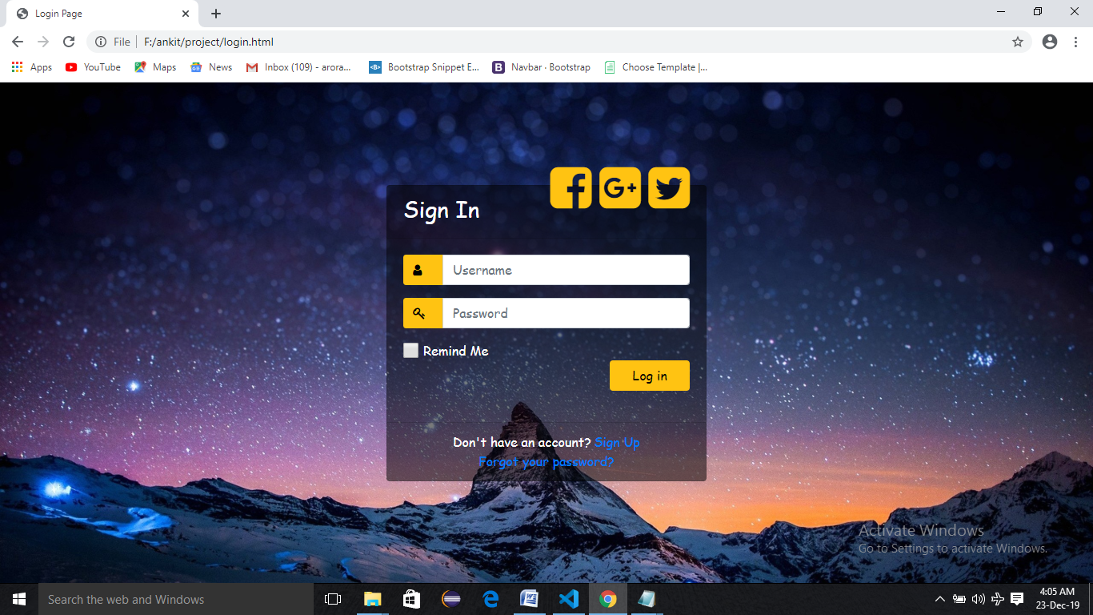

1. **Signup page:**

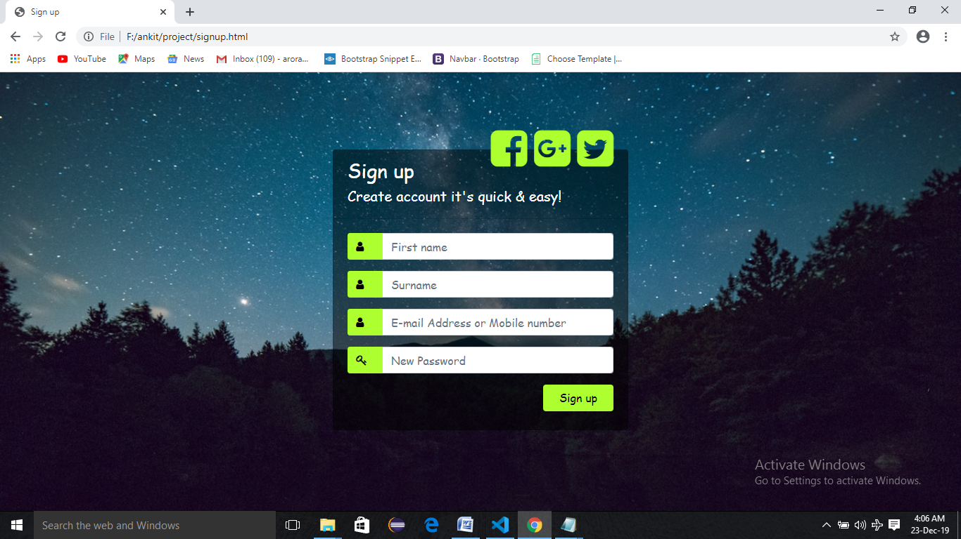

1. **Home page:**

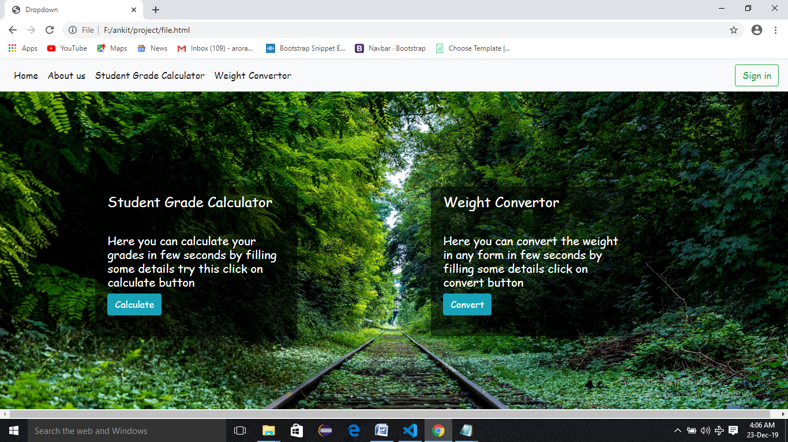

1. **Student grade calculator:**

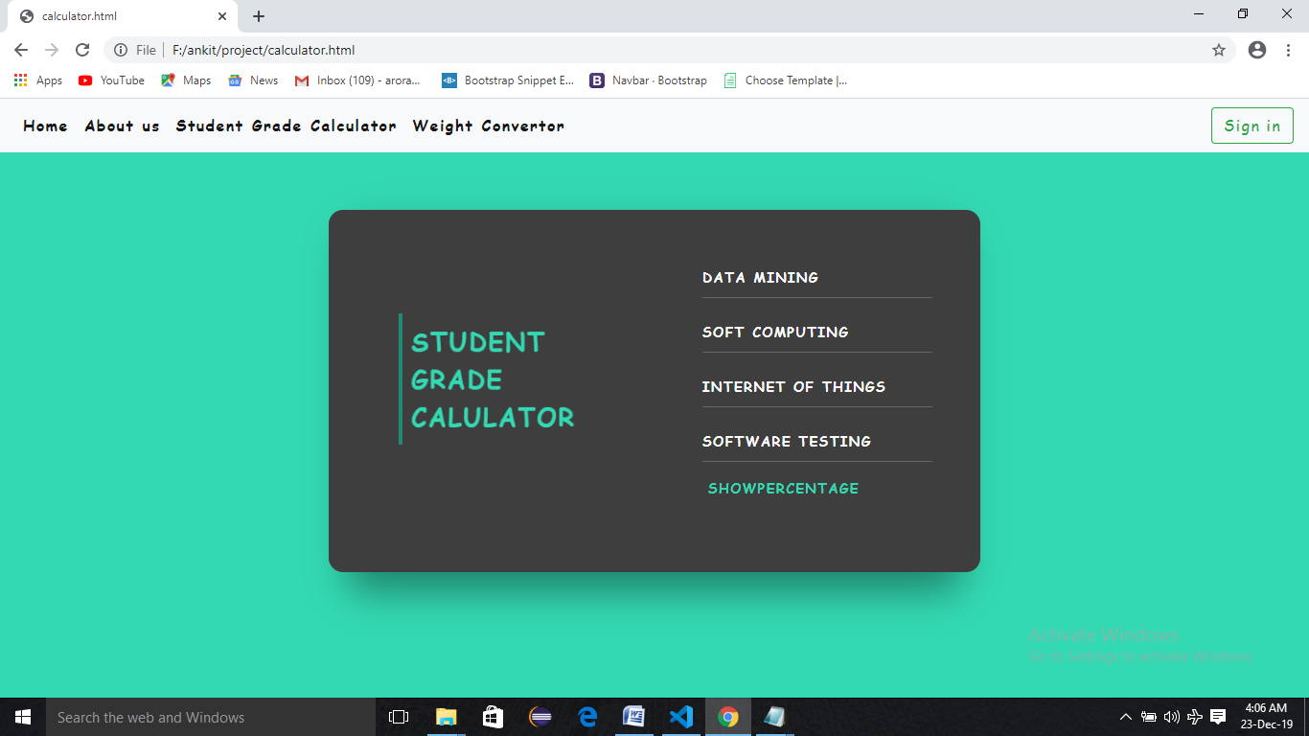

1. **Weight Convertor:**

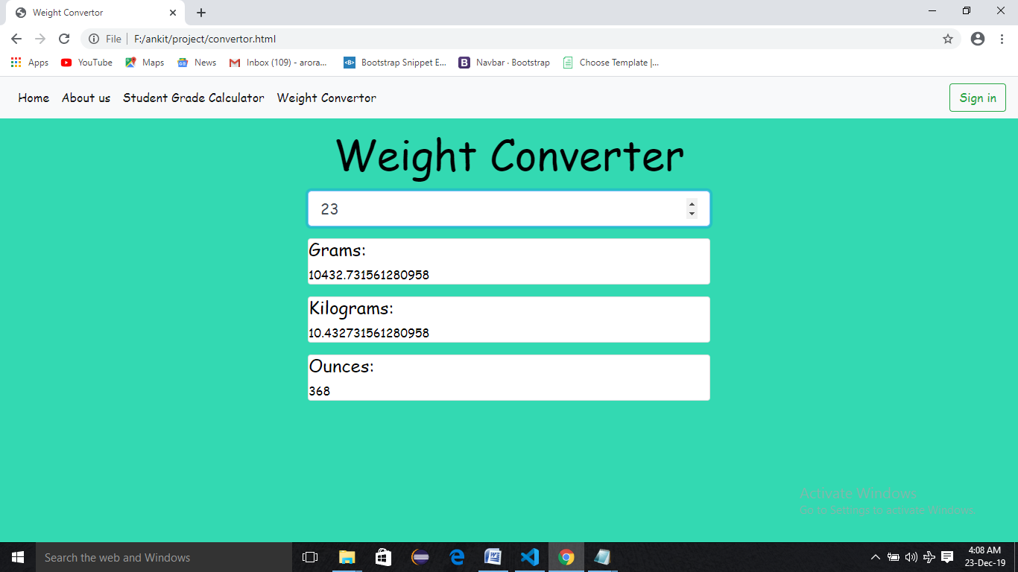

1. **About us:**

